

Topic test 2
Name: __________________________________

Chapter 5: Conditional probability

• Time allowed: 45 minutes
• CAS calculators may be used.
• Part A: 5 multiple-choice questions (5 marks)
• Part B: 5 short answer questions (29 marks)
• Part C: 2 analysis questions (22 marks)
Part A
5 multiple-choice questions
1 mark each: 5 marks
Circle the correct answer.
1 A mesh bag of 15 navel oranges actually has 3 valencia oranges in it. If the first three oranges taken from the bag are navels, what is the probability that the next will be a valencia?
A
B
C
D 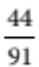
E 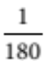

[1 mark]
2 A bus picks up tourists from different locations in Melbourne for a tour of the Dandenongs. Four are picked up at the Domain Interchange, eight at Federation Square, six at Southern Cross Station, and six outside the Victoria Markets. After the first stop, they get back on the bus in random order. What is the probability that the first three back on the bus are tourists who were picked up at Federation Square?
A
B
C 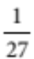
D 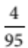
E 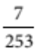

[1 mark]
3 What is the probability of getting a total of 5 twice in a row when two normal 6-sided dice are rolled?
A 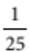
B 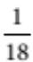
C 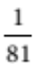
D 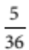
E 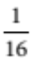

[1 mark]
4 What is the probability that a coin weighted to give heads 60% of the time will land with heads up three
times in a row?
A 0.18
B 0.006
C 0.216
D 0.64
E 0.2

[1 mark]
5 20% of cars are yellow and 80% are 4-door. All the cars have 2 or 4 doors. What is the probability that the next car you see will be a yellow 2-door car?
A 16%
B 4%
C 12%
D 40%
E 36%

[1 mark]
Part B
5 short answer questions
29 marks
Show your working where appropriate.
1 Two cards are taken from a normal 52-card pack.
a Given that the first card is a number card, what is the probability that the next is also a number card?

b What is the probability that both cards are number cards?

[4 marks]
2 A mobile beach-hire van has boogie boards, paddleboats, surf skis and large inner tubes for hire. Given that the items are equally popular, what is the probability that the next three hirers will all want a surf ski?

[3 marks]
3 Two random counters are taken out together from a bag. There are 4 red, 7 blue and 5 white counters in the bag.
a What is the probability that both of the counters will be white?

b What is the probability that they will be different colours?

[6 marks]
4 The numbers of boys and girls competing in one of the field events at 11.14 a.m. at a school sports carnival are shown in the following table. Obviously, each event is running for a different age-group at that time.
 | High jump | Long jump | Shot put | Javelin
Boys | 8 | 17 | 6 | 12
Girls | 10 | 10 | 9 | 6
a Given that a student is doing the high jump, what is the probability that the student is female?

b Given that a student is female, what is the probability she is competing in the high jump?

c What is the probability that a student selected at random is a girl doing the high jump?

d What is the probability that a boy selected at random is competing in the shot-put at 11.14 a.m.?

[8 marks]
5 At the school sports carnival, 30 students from Year 11 are competing in field events. Nine are doing all three of the high jump, long jump and triple jump. Fifteen are doing the high jump and of these, two are
doing the long jump but not the triple jump. There are four students competing in field events that are not either the long jump, high jump or triple jump. Nineteen students are doing the triple jump, and 4 of these are not competing in the long jump or high jump. Only two of the students doing the high jump are not competing in the triple jump or long jump.
a If a student is doing the high jump, what is the probability that they are also competing in the
triple jump?

b How many students are competing in the long jump?

c What is the probability that a student is doing both the long jump and high jump?

d Given that a student is doing the long jump, what is the probability that the student is also doing the triple jump?

[8 marks]
Part C
2 analysis questions
22 marks
Show your working where appropriate.
1 A factory making electric motors has three robots that do the coils on the rotors. The robot installed
5 years ago works at a third of the rate of the new one, and the new one works twice as fast as the
3-year-old robot. The quality control section reveals that 8% of the rotors with coils done by the oldest robot are faulty, while only 2% of those done by the new one are faulty. 43 of the last 1100 rotors produced in the factory have faulty rotor coils.
a How many of the rotors had each robot done the coils on?

b How many faulty coils were produced by the new robot?

c How many faulty coils were produced by the oldest robot?

d What was the percentage of the coils produced by the 3-year-old robot that were faulty?

e Given that a rotor coil is faulty, what is the probability that it was produced by the 3-year-old robot?

[10 marks]
2 Blood tests are generally quite reliable, but because they often test for minute quantities of antibodies, contamination is a problem, so they are not 100% correct.
A particular blood test for a relatively rare condition has a 95% success rate. That is, it is correct 95% of the time, whether the result is positive or negative.
The disease that this blood test is for occurs in only 0.5% of the population.
However, the disease occurs in about 20% of cases sent in for testing by experienced GPs or specialists.
a In a mass screening program, what is the probability that a blood test will be from a person with the disease and be positive (a true positive)?

b In a mass screening program, what is the probability that a blood test will be from a person without the disease and be positive (a false positive)?

c What is the probability of a positive test from a mass screening program?

d What is the probability that a positive test from a mass screening program will be correct?

e What is the probability that a blood test sent in by an experienced doctor will be from a person without the disease and be positive?

f What is the probability that a positive result from a blood sample sent in by an experienced doctor will be correct?

[12 marks]
Total marks: 56
Answers
Part A [1 mark each]
1 There are 12 left, of which 3 are valencias, so P(Next valencia) 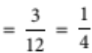
 A [1 mark]
2 P(3 Federation square) 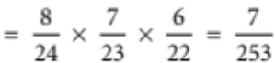
 E [1 mark]
3 There are 4 out 36 ways to get a total of 5, so P(total 5) 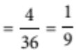
The rolls are independent so P(2 totals of 5) 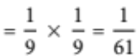
 C [1 mark]
4 The tosses are independent, so P(3 heads) = 0.6 × 0.6 × 0.6 = 0.216
 C [1 mark]
5 Since colours and number of doors are independent,
P(Yellow and 2-doored) = 0.2 × 0.2 = 0.04 = 4%
 B [1 mark]
Part B
1 a P(2nd number | 1st number) 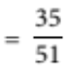 [2 marks]
b P(2 numbers) 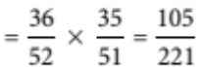 [2 marks]
[4 marks]
2 They are independent, so P(3 surf skis) 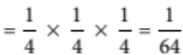 [3 marks]
3 a P(both white) 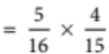
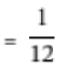 [2 marks]
b P(both red) 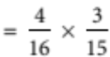
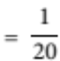
P(both blue) 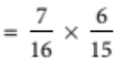
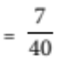
P(different colours) 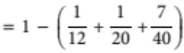
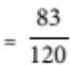 [4 marks]
[6 marks]
4 a P(female | high jump) 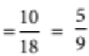 [2 marks]
b P(high jump | female) 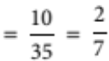 [2 marks]
c P(high jump and female) 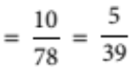 [2 marks]
d P(shot put | male) 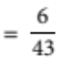 [2 marks]
[8 marks]
5 The Venn diagram is:
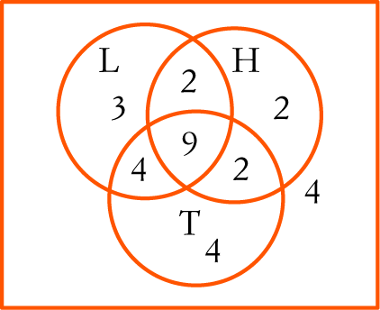
a P(triple | high) =  [2 marks]
b 18 [2 marks]
c P(long and high) = 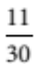 [2 marks]
d P(triple | long) = 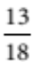 [2 marks]
[8 marks]
Part C
1 a Let n be the number produced by the new robot.
Then and are produced by the 3-year-old and the 5-year-old robot in the same time.
Total 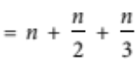.
For the last 1100, 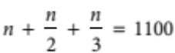
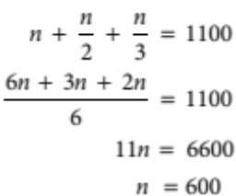
Thus, the numbers produced were: new: 600, 3-year-old: 300, 5-year-old: 200. [2 marks]
b n(faulty and new) = 2% × 600 = 12 [2 marks]
c n(faulty and oldest) = 8% × 200 = 16 [2 marks]
d n(faulty and 3-year-old) = 43 – 12 – 16 = 15 [2 marks]
So faulty% 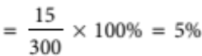
e P(3-year-old | faulty) 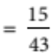  0.308 [2 marks]
[10 marks]
2 a P(positive and disease) = 0.95 × 0.005 = 0.00475 [2 marks]
b P(positive and no disease) = 0.05 × 0.995 = 0.04975 [2 marks]
c P(positive from mass screening) = 0.00475 + 0.04975 = 0.0545 [2 marks]
d P(mass screening correct | positive) 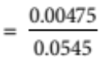  0.0872 = 8.72% [2 marks]
e P(Doctor sent, no disease and positive) = 0.8 × 0.05 = 0.04 [2 marks]
f P(Doctor sent, disease and positive) = 0.2 × 0.95 = 0.19
P(Doctor sent and positive) = 0.04 + 0.19 = 0.23
P(doctor sent correct | positive) 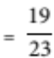  0.826 = 82.6% [2 marks]
[12 marks]

